|  |  |  |
| --- | --- | --- |
|  | SRM INSTITUTE OF SCIENCE AND TECHNOLOGY  SCHOOL OF COMPUTING  DEPARTMENT OF DATASCIENCE AND BUSINESS SYSTEMS  21GNP301L Community Connect |  |
| WORK REPORT | | |
| Name: Ponnuri Aniruddha  Register Number: RA2112704010015  Mail ID: pp0783@srmist.edu.in  Department: Data science and business systems  Specialization: data science  Semester: 5 | | |
| NGO NAME and details  **Shraddha Foundation**  **H.NO. 946, SECTOR-15, FARIDABAD (HARYANA)**  **Mob: 9818076444, 9810651488**  **E-mail: shraddha.foundation12@gmail.com** | | |

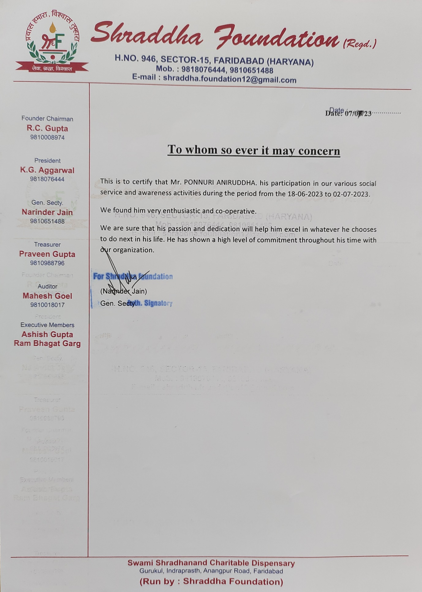

Introduction:

Over the course of two weeks, I participated in two distinct community service initiatives: one at an orphanage to make a positive impact on the lives of underprivileged children, and the other a week-long plantation project to contribute to environmental conservation. At the orphanage, I had the opportunity to interact with the children on a daily basis and assist them with their various needs. I provided academic support, facilitated recreational activities, and mentored the children to develop their social and emotional skills. It was incredibly rewarding to witness their growth and to know that I was making a difference in their lives. In addition to my work with the children, I also contributed to the overall well-being of the orphanage by maintaining its facilities. I clean and organize living spaces, prepare meals, and help with other general tasks. I am grateful for the opportunity to create a safe and nurturing environment for children. During my second week of community service, I participated in a week-long farming project. This initiative involves planting trees and other vegetation in degraded areas to restore them to their natural state. I worked alongside other volunteers to plant hundreds of seedlings and care for them over the following days and weeks. The tree planting project is both challenging and rewarding. It was physically demanding work but also incredibly satisfying to see the progress we made during the week. We have planted a range of native trees and shrubs, which will help improve the biodiversity of the area and provide food and shelter for wildlife.

Motivation:

From an early age, my unwavering passion has been centred around assisting others and creating a constructive influence on the world. Upon being presented with the chance to lend a helping hand at both an orphanage and a plantation project, I immediately realized that I simply could not pass up on the opportunity to get involved.My inclination to volunteer at an orphanage from my deep desire to assist children who face adversity, lacking the same privileges as their counterparts. In my opinion, it is a fundamental right for every child to have a secure and affectionate home, and I am committed to aiding in the provision of such environments for them. While working at the orphanage, I had the chance to engage with children spanning different age groups. I offer assistance in their homework, partake in games together, and enjoy spending time with them. Their resilience and strength left me in awe, while their unwavering determination to succeed filled me with inspiration. I am driven to participate in the tree planting project due to my deep-seated passion for environmental conservation. In my perspective, it is incumbent upon us to safeguard our planet for the benefit of the forthcoming generations. Tree planting projects involve the act of planting trees and other types of vegetation in areas that have undergone degradation, aiming to bring them back to their original and natural condition. I had the opportunity to collaborate with fellow volunteers in planting numerous seedlings and providing ongoing care for them over the subsequent days and weeks. It is truly gratifying to witness the significant advancements we have achieved throughout the course of this week.

Work Report

1st week: community service in the orphanage

As my first community service at the orphanage, I introduced myself to the children and staff. I was immediately amazed by the warmth and enthusiasm of the children. They were eager to learn and experience new things. I began my work by completing a course on self-knowledge and self-esteem. I wanted to help children understand their unique strengths and talents. I also wanted to encourage them to believe in themselves and their potential. The children responded well to the class. They were engaged and enthusiastic. They freely shared their thoughts and experiences. It was clear that they wanted to learn more about themselves and grow as individuals. In addition to the self-knowledge and self-evaluation class, I organized various fun activities for the children. We played games, sang songs and did crafts. I also spent time just talking to the kids and getting to know them. One of the most rewarding aspects of my orphanage experience was mentoring the children. I had the opportunity to work with many different children, helping them with homework, providing emotional support and guidance. My experience at the orphanage was incredibly rewarding. It was an honour to work with the children and help them develop to their full potential. I learned a lot about myself and the importance of giving back to the community.

Week 2: Environmental Planting Project

In the second week of community service, I participated in an environmental planting project. The aim of the project was to restore the degraded area by planting trees and other vegetation. On the first day, we did a site assessment to find suitable areas to plant trees. We also communicated with the local authorities to obtain the necessary permits. On the second day, we started planting trees. Together with other volunteers we planted hundreds of saplings. We also learned about the care and maintenance of trees. On the third day, we worked with the local community and involved them in planting. This helped create community unity and a sense of responsibility for environmental protection. On the fourth day, we organized an educational event for the children, where they learned about the importance of planting trees and its environmental effects. We discussed the benefits of trees in terms of biodiversity, mitigating climate change and improving air and water quality. On the last day of the planting project, we held a closing ceremony to thank the children and volunteers for their efforts. Certificates of participation were distributed and the planted trees were monitored and cared for. My participation in the environmental plantation project was a valuable learning experience. I understood the importance of environmental protection and the role that individuals can play in bringing about change. I also learned about the importance of collaboration and community in achieving sustainable development goals.

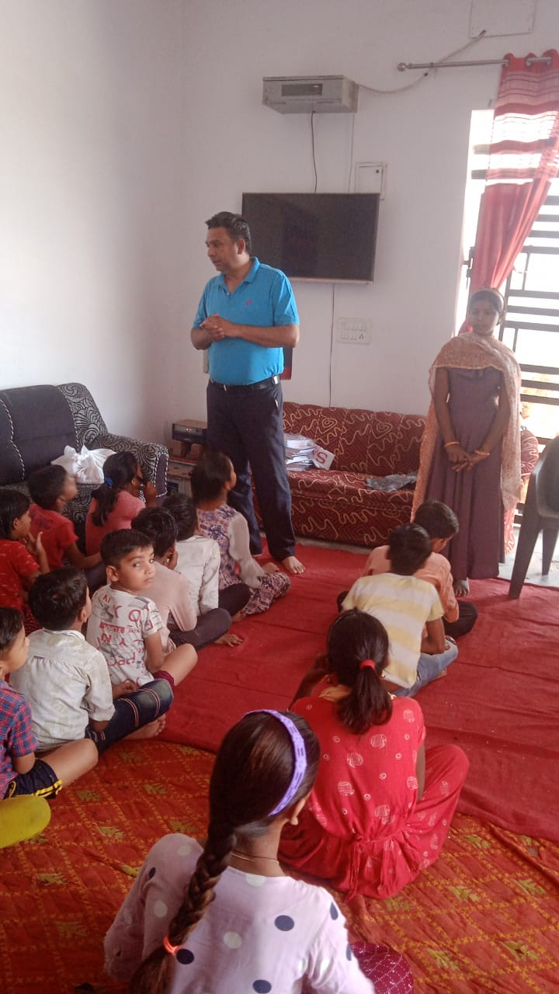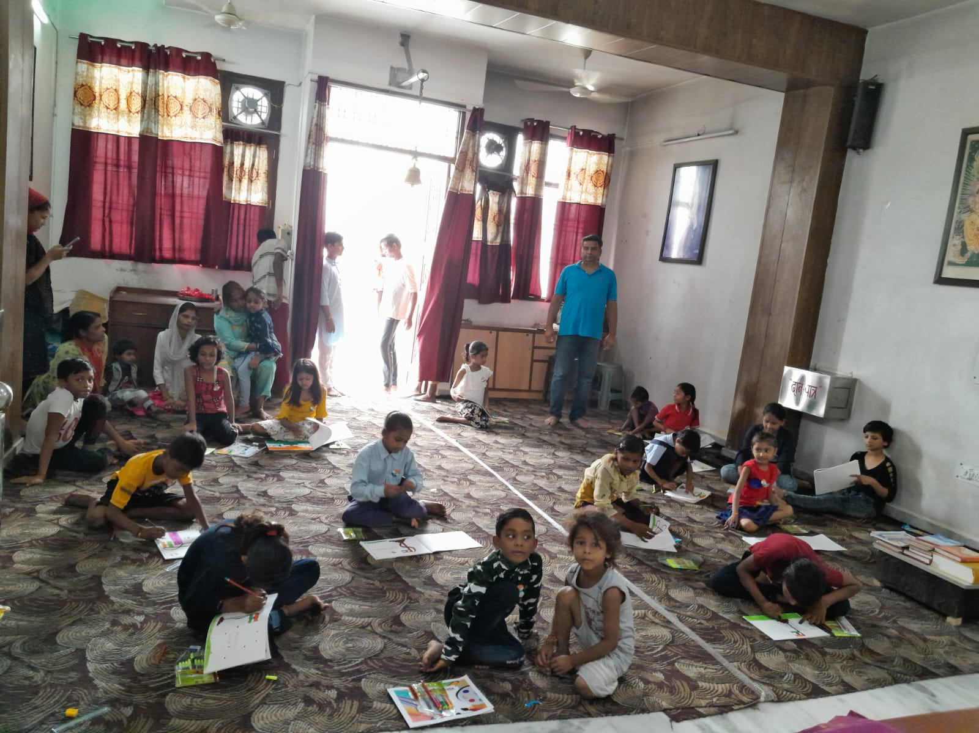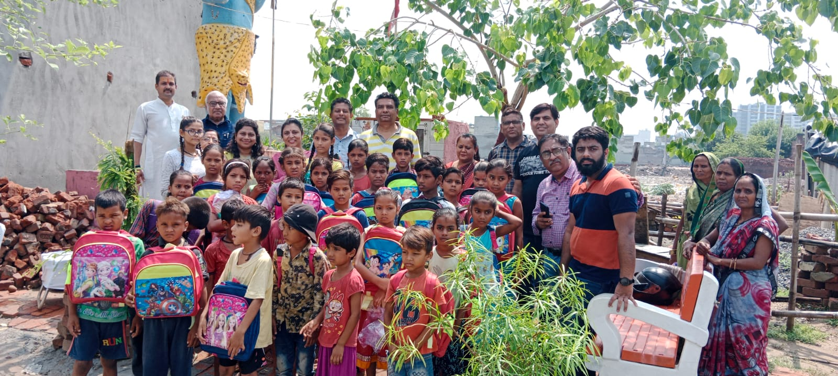

Some suggestions to improve your volunteering work:

* Be prepared. Before you start volunteering, take some time to learn about the organization and the role that you will be playing. This will help you to be more effective and to make a greater impact.
* Be reliable. Show up on time and be prepared to work hard. Volunteering is a commitment, and it is important to be reliable and dependable.
* Be flexible. Things don't always go according to plan, so it is important to be flexible and adaptable. Be willing to help out wherever you are needed.
* Be positive. A positive attitude is contagious. Be enthusiastic and supportive of your fellow volunteers.
* Be respectful. Treat everyone with respect, regardless of their age, background, or position.
* Be open to feedback. Be receptive to feedback from the organization and from other volunteers. This will help you to improve your work and to be more effective.
* Be willing to learn. Volunteerism is a great opportunity to learn new skills and knowledge. Be open to new challenges and be willing to step outside of your comfort zone.